# PROFESSIONAL TRAINING REPORT

at

# SATHYABAMA INSTITUTE OF SCIENCE AND TECHNOLOGY

## (Deemed to be University)

Submitted in partial fulfillment of the requirements for the award of Bachelor of Engineering Degree in Computer Science and Engineering

by

**PASHAM VYSHNAVI**

**(Reg no:40111456)**



# DEPARTMENT OF COMPUTER SCIENCE AND ENGINEERING S OF COMPUTING

**SATHYABAMA INSTITUTE OF SCIENCE AND TECHNOLOGY**

**JEPPIAAR NAGAR, RAJIV GANDHI SALAI,**

# CHENNAI – 600119, TAMILNADU

**MARCH 2023**

SATHYABAMA

## INSTITUTE OF SCIENCE AND TECHNOLOGY

**(DEEMED TO BE UNIVERSITY)**

**Accredited with Grade “A” by NAAC** (Established under Section 3 of UGC Act, 1956) JEPPIAAR NAGAR, RAJIV GANDHI SALAI, CHENNAI– 600119

[**www.sathyabama.ac.in**](http://www.sathyabama.ac.in/)

## DEPARTMENT OF COMPUTER SCIENCE AND ENGINEERING

**BONAFIDE CERTIFICATE**

This is to certify that this Project Report is the bonafide work of **PASHAM VYSHNAVI (Reg. No: 40111456)** who carried out the project entitled “**VIDEO STREAMING MANAGEMENT**” under my supervision from Jan 2023 to April 2023

## Internal Guide

**Mrs**. **ASHA JUDI.V M.E.**

## Head of the Department

**Dr. L. Lakshmanan, M.E., Ph.D.,**

## Submitted for Viva voce Examination held on



**Internal Examiner External Examiner**

# DECLARATION

I, **PASHAM VYSHNAVI** hereby declare that the project report entitled “**VIDEO STREAMING MANAGEMENT”** done by me under the guidance of **Mrs**. **ASHA JUDI.V M.E.** is submitted in partial fulfillment of the requirements for the award of Bachelor of Engineering Degree in Computer Science and Engineering.

## SIGNATURE OF THE CANDIDATE

**DATE:**

**PLACE:**

# ACKNOWLEDGEMENT

I am pleased to acknowledge my sincere thanks to the Board of **Management of SATHYABAMA** for their kind encouragement in doing this project and for completing it successfully. I am grateful to them.

I convey my thanks to **Dr. T. Sasikala M.E., Ph.D.**, **Dean**, School of Computing, **Dr. L. Lakshmanan, M.E., Ph. D. and Dr. S. Vigneshwari, M.E., Ph.D., Heads of the Department** of **Computer Science and Engineering** for providing me necessary support and details at the right time during the progressive reviews.

I would like to express my sincere and deep sense of gratitude to my Project Guide **Mrs**. **ASHA JUDI.V M.E** for her valuable guidance, suggestions and constant encouragement paved the way for the successful completion of my project work.

I wish to express my thanks to all Teaching and Non-teaching staff members of the **Department of Computer Science and Engineering** who were helpful in many ways for the completion of the project.

# ABSTRACT

Video streaming management involves the process of delivering high-quality video content to end-users over the internet. The management of video streaming involves several tasks such as encoding, transcoding, content delivery, and video quality monitoring. In order to provide a seamless streaming experience, several technologies such as adaptive bitrate streaming, content delivery networks, and video player integration are used.

The success of video streaming management largely depends on the ability to efficiently manage the infrastructure, optimize video delivery, and ensure a consistent streaming experience across different devices and platforms. Video streaming management also involves ensuring compliance with legal and regulatory requirements related to content distribution and copyright protection.

The key challenges of video streaming management include dealing with latency issues, managing the quality of service, and ensuring scalability to handle large numbers of concurrent users. In addition, video streaming management requires continuous monitoring and optimization to ensure that the streaming service remains competitive and provides the best possible user experience.

To address these challenges, video streaming management solutions incorporate advanced analytics, machine learning, and artificial intelligence technologies to optimize video delivery and provide real-time monitoring and analytics. These solutions also enable content providers to personalize the streaming experience based on user preferences and behavior.

In conclusion, video streaming management is a complex and constantly evolving field that requires a deep understanding of video delivery technologies, infrastructure management, and user behavior. The success of video streaming management depends on the ability to deliver high-quality content, provide a seamless streaming experience, and continuously optimize video delivery to meet the changing needs of users.

**TABLE OF CONTENTS**

|  |  |  |
| --- | --- | --- |
| **CHAPTER NO.** | **TITLE** | **PAGE NO.** |
|  | ABSTRACT | IV |
|  | LIST OF FIGURES | VI |
|  |  |  |
|  | LIST OF ABBREVATIONS | VIII |
| **1.** | **INTRODUCTION** | **8** |

* 1. Existing system
  2. Proposed system
  3. Hardware and software
  4. Feasibility study

## AIM AND SCOPE OF THE 12

**PRESENT INVESTIGATION**

* 1. Aim
  2. Objectives
  3. Choice of methodology

## EXPERIMENTAL OR MATERIALS 19

**AND METHODS**

* 1. Methods
  2. Project category
  3. Types of streaming

## SOURCE CODE & OUTPUT SCREENSHOTS 27

1. **CONCLUSION & REFERRENCE 58**

|  |  |  |
| --- | --- | --- |
|  | **LIST OF FIGURES** |  |
| **FIGURE NO** | **FIGURE NAME** | **PAGE NO** |
| 1.2 | PROCESS OF VIEDO STREAMING | 09 |
| 1.4 | DATA FLOW DIAGRAM | 11 |
| 2.2 | NETWORK OF VIEDO STREAMING | 12 |
| 2.3 | METHODOLOGY OF VIEDO STREAMING | 13 |
| 3.1 | TRANSCODE OF VIEDO STREAMING | 20 |
| 3.2 | PRE-ENCODED VIEDO STREAMING | 22 |
| 3.3 | CONTENT DELIVERY NETWORK | 25 |
|  |  |  |
|  |  |  |
|  |  |  |

# LIST OF ABBREVATIONS

|  |  |
| --- | --- |
| **ABBREVIATION** | **EXPANSION** |
| DFD | Data Flow Diagram |
| MYSQL | My Structured Query Language |
| PHP | Hypertext Preprocessor |
| RAM | Random-access memory |
| VBR | Variable bit rate |
| UDP | **User Datagram Protocol** |
| TCP | **Transmission Control Protocol** |
| RTMP | Real-Time Messaging Protocol |
| RTSP  CDN | Real-Time Streaming Protocol  **Content Delivery Networks** |

**CHAPTER 1 INTRODUCTION**

The Project entitled “Video Streaming” is an application that allows the users to add videos. The users those who wish to add videos, can register for the website and get the User ID and password. Video Streaming is a web application allow the users to browse the videos, and at same time. It provides the user up to date information at any appropriate location.

**1.1 EXISTING SYSTEM**

The earlier system is not computerized. The process of adding the videos is very difficult when done manually users face so many problems in uploading videos. Here now such type of preplanned applications is not there for users.

Drawbacks of Existing System:

* Difficulty in adding videos manually.
* Doesn’t provide effective mechanism
* Difficulty in browse the all the information.

1.2 PROPOSED SYSTEM:

The proposed system is fully computerized, which removes all the drawbacks of existing system. In the proposed system, the users can add the videos very easily.

Advantages of the proposed system:

* Managing the levels is very easy
* Storing the Videos is so easy.
* Giving input is as simple as just a single mouse click
* Easy to maintain up to date information.
* Cheaper to maintain.
* No manual tracking is required.

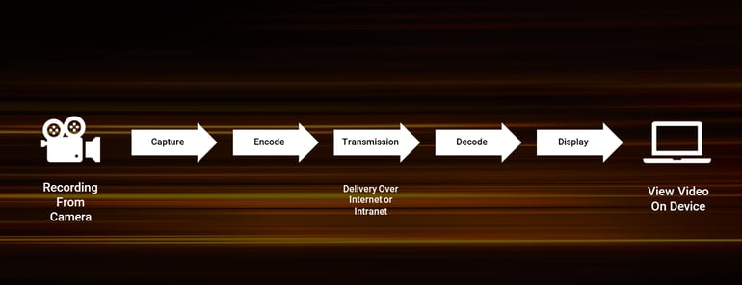

Fig 1.2: Process of video streaming

**1.3 Hardware and software specifications**

SOFTWARE REQUIREMENTS

OPERATING System **:** WINDOWS XP

Data Base **:**  MYSQL

Programming Language **:** PHP

Server **:** APAChe

HARDWARE REQUIREMENTS

PROCESSOR  **:** P-III or Above

RAM **:** 512MB

HARD DISK **:** 40GB

1.4 FEASIBILITY STUDY:

Feasibility study is an important phase in the software development process. It enables the developer to have an assessment of the product being developed It refers to the feasibility study of the product in terms of outcomes of the product, operational use and technical support required for implementing it.

Feasibility study should be performed on the basis of various criteria and parameters. The various feasibility studies are:

* Economic Feasibility
* Operational Feasibility
* Technical Feasibility

**Economic Feasibility:** It refers to the benefits or outcomes we are deriving from the product compared to the total cost we are spending for developing the product. If the benefits are more or less the same as the older system, then it is not feasible to develop the product.

In the present system, the development of the new product greatly enhances the accuracy of the system and cuts short the delay in the processing of application.

The errors can be greatly reduced and at the same time providing a great level of security. Here we don’t need any additional equipment except memory of required capacity. No need for spending money on client for maintenance because the database used is web enabled database.

**Operational Feasibility:** It refers to the feasibility of the product to be operational. Some products may work very well at design and implementation but may fail in the real time environment. It includes the study of additional human resource required and their technical expertise.

In the present system, all the operations can be performed easily compared to existing system and supports for the backlog data. Hence there is need for additional analysis. It was found that the additional modules added are isolated modules as far as the operational is concerned, so the Developed system is operationally feasible.

**Technical Feasibility:** It refers to whether the software that is available in the market fully supports the present application. It studies the pros and cons of using particular software for the development and its feasibility. It also studies the additional training needed to be given to the people to make the application work.

In the present system, the user interface is user friendly and does not require much expertise and training. It just needs a mouse click to do any sort of application. The software that is used for developing is server pages fully is highly suitable for the present application since the users require fast access to the web pages and with a high degree of security. This is achieved through integration of web server and database server in the same environment.

**Implementation plan:**

The main plan for the system developed is to upgrading existing system to the proposed system. There are mainly 4 methods of upgrading the existing system to proposed

* Parallel Run System
* Direct Cut-Over System
* Pilot System
* Phase-in Method

**Parallel Run System:** It is the most secure method of converting from an existing to new system. In this approach both the systems run in parallel for a specific period of time. During that period if any serious problems were identified while using the new system, the new system is dropped and the older system is taken at the start point again.

**Direct Cut -Over Method:** In this approach a working version of the system is implemented in one part of the organization such as single work area or department. When the system is deemed complete, it is installed throughout the organization either all at once (direct cut-over) or gradually (phase-in).

**Phase-in Method:** In this method a part of the system is first implemented and over time other remaining parts are implemented.

**Implementation planed used:** The workflow Management system is developed on the basis of “Parallel Run Method” because we upgraded the system, which is already in use to fulfill the requirements of the client. The system already in use is treated as the old system and the new system is developed on the basis of the old system and maintained the standards processed by the older system. The upgraded system is working well and is implemented on the client successfully.

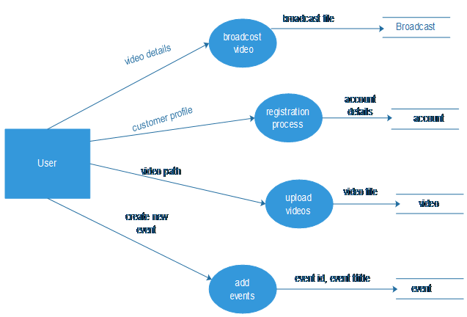

Fig 1.4: Data flow diagram of video streaming management

# CHAPTER 2

## AIM AND SCOPE OF THE PRESENT INVESTIGATION

## AIM:

## Streaming video is one way to deliver video over the Internet. Though far from a perfect solution, streaming video technology is becoming more powerful all the time. Streaming video allows the user to view video over the Internet as it downloads, instead of waiting until the entire file is downloaded to the computer.

## OBJECTIVE:

Factors affecting Video Streaming Projects

* Development in streaming servers.
* Advances in compression algorithm for audio and video.
* Improvements in broadband networks and in cable modems.

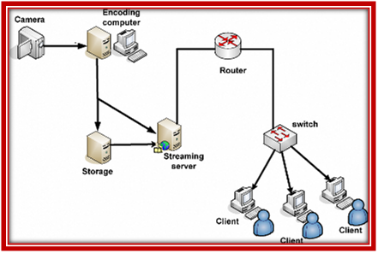

Fig 2.2: Network of video streaming

Video streaming projects features*:*

* It can benefit from using broadcast and multicast approaches.
* It can deliver live content such as a football match, a concert or a political speech.
* Allows for streaming tracks to be included in otherwise non-streaming content.
* Provides random access to long movies.
* It only uses the exact network bandwidth it really needs.
* It occupies no space on the user’s hard disk.

**2.3 CHOICE OF METHODOLOGY:**

Streaming video and audio are a constant process of receiving content via a delivery network form a provider to an end user. You can obtain audio visuals even without the whole file on your system, since it gets streamed bit by bit to the client. It’s an alternative to downloading, where you can only watch the content once it has been fully obtained as a whole file in the client system. It reduces setup time and client storage requirement, and is view-able in real time.

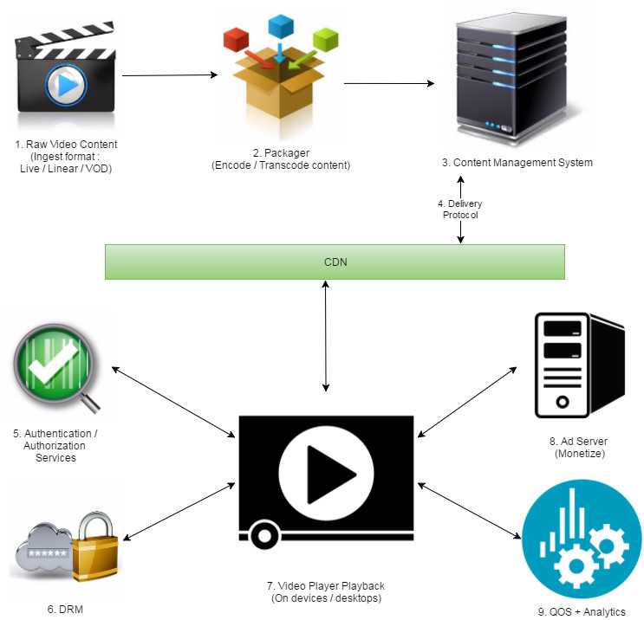

Fig 2.3: Methodology of video streaming

1. Content Creation / Capture

The first step is to create / capture the content that you want to stream. Below are the points to remember when generating content -Resolution - These are the number of distinct pixels displayed in each dimension. For example: 1280 x 780 etc. Quality / Display Standard - These are a set of parameters that determine the quality of video. It includes display resolution, pixel aspect ratio and color depth. For e.g.: VGA, HD, 4K UHD etc.

Type - What kind of content is it? Live (Real time), VOD (video on demand: streaming a file stored on a system by breaking them into stream-able component) or Linear (VOD content streamed in live fashion).

Method - How of the process. E.g.: usage of video capture card that can convert the analog signals to digital form and compresses the data. Input / Output Format - These are the container formats selected prior to streaming. These would define container specification for audio and video. E.g.: AVI, ActiveMovie, Cinemas, Indio, motion-JPEG, flu, move, mp4, 3gp, TS etc.

Codecs - These are coding techniques to compress video data. E.g., of Video codecs as MPEG, H.261 (teleconferencing applications), H.263 (low bit-rate communication, supports 5 resolutions). Audio codec such as AAC or MP3.

Frame Rates - Considering video to be a compilation of images (or frames), frame rate is the number of such frames showed on screen per second. E.g.: One would use 11-14 fps for video conferencing whereas 30 fps for full motion video. Protocol - RTMP, HLS, HDS Keyframe Frequency / interval - Keyframe is the full frame of an image. Subsequent frames (p-frames) have information about what has changed between each frame or "delta". Keyframes are placed at regular intervals throughout a video; these intervals are set in the encoder and is called keyframe frequency. E.g., it’s between 1 to 4 seconds for live streaming. Bitrate / data rate - It is the data rate specification for video content that runs at x bits per second. A higher bitrate accommodates higher image quality in the video output. E.g., 8 megabits per second (8 mbps) of audio or video.

Bitrate Encoding - Constant bit rate (CBR) encoding persists same data rate over the whole video clip. Useful when there is similar motion level across the entire video. Variable bit rate (VBR) encoding adjusts the data rate as per the motion level in the clip. It produces the most favorable results. Audio channel - mono / stereo.

Profile - The encoder and decoder agree on a feature set that they can both handle. They can be high, baseline or main.

2. Content Formatting (Compression) / Packaging Once you have decided what kind of content needs to be streamed, we need to package this properly as per necessity. Content now needs to be encoded (analog to digital conversion of data) and / or transcoded (digital to digital conversion of data). Hardware encoders (Tirade, Harmonic, Elemental, Cisco etc.), software encoders (Wire cast, Adobe Flash Media Live Encoder, Podcaster, QuickTime Broadcaster) are responsible to generate required renditions of the same content depending upon bitrates chosen by the user. One can also use Cloud encoders like: encoding.com, Zen coder, and intraplane to generate various formats like: RTMP, RTP, RTSP.Published stream are fed to packaging servers e.g.: Adobe Media Server, Wowzah or Adobe Primetime Packager. They create content understandable by devices e.g., HDS, HLS, or DASH. One can also use mediastreamsegmenter command-line tool with MPEG-2 TS input file and generate series of equal-length files to enable HTTP Live Streaming.

Transcoding is used to convert once digital video file format to the other (e.g., between mp4 to flu). This is not an absolute necessity, but certain video frameworks can crunch a format better than the other. One can create profiles of multi bitrates such as 64kbps, 2K/4K, 4Mbps or 8Mbps. They should follow the profiles as per requirement of various client end devices.

3. Content Management: This is a critical component of the video server architecture. This is used to catalog, organize, store, create, collect, add thumbnails, make comments, create playlists, editing video by trimming and access multimedia information. E.g., OOyala, Brightcove, the platform, Kaltura, dialog, YouTube etc. One can ingest VOD content, create live episodes, generate and map ad timelines on them, chose video player type, serve specific analytics services. Most high-end OVPs will assign different rights and capabilities to different users. These user data can be used by the video player to create personalized ads.

4. Delivery / Distribution: Once the packaged data is ready to be seen by the world, we need a proper distribution mechanism. The delivery platform one choses would be the primary cause of good performance of the architecture. One can use many protocols available in the market: TCP, HTTP, UDP. Some real time transmission protocols are: RTP, VDP, RTSP, RSVP. HLS, HDS, RTMP. We have to make sure load balancers are placed, support for failover and traffic management is available.

The structure should also be scalable to handle traffic of million users. Caching servers and CDNs are an efficient way to optimize video delivery. e.g.: Akamai, Level3, Limelight, Amazon (ec2 instances with CloudFront caching), Edge cast. User can deliver various streaming formats of the same content with ease of scalability and optimum performance.

5. Content Entitlement - Authentication / Authorization Subscribers should be able to access the content they are already paying for, across multiple devices and platforms, both in and out of their homes. There is a requirement to entitle the user who watches content between the Programmer + Publisher (CNN, Hulu, AMC etc.) and such Pay TV providers (AT&T, Charter, Verizon etc.).

Before a viewer accesses subscription content, this component determines whether they are entitled to that access. It is two parts in nature: Authentication - does the user have a subscription with a Pay TV provider? Authorization - does that subscription include the content that is being requested? the Platform’s TVE (TV Everywhere), Akamai and Adobe Pass provide such products in the industry.

6. View Control - Content protection (DRM): This is one of the most crucial components to ensure the safety and security of the content delivery itself. A premier content owner is worried about piracy and hack to their content. DRM (Digital Rights Management) is the way to go. Some examples are: Adobe AAXS, Apple Fair play, Microsoft PlayReady and Google Wide vine.

This is the practice of imposing technological restrictions that control what users can do with the digital video. It should support policies to control viewing of content by preventing copying, specifying a time period in which the content can be accessed or limits the number of devices the media can be installed on (Restrictive Licensing Agreement and encryption methodologies).

7.Decoding + Presentation / Viewing: The transferred data is decoded and played back in this part of the component. The decoder is a stand-alone player or a plugin that works as part of a web browser. The server, information stream and decoder work together to let people watch live or prerecorded broadcasts.

There are many features one looks for in a good player: streaming format support, subtitles, thumbnails, playlist creations, bitrate change, resolutions/quality change, multiple audio languages, closed captioning, trick play, ABR switching, autoplay, sharing to social networking, volume, play / pause. E.g., of Video player SDKs: Adobe Primetime TVSDK, Google IMA SDK, Kaltura SDK, Instreaming, Visual On, Microsoft Azure Media Player, Brightcove, OOyala, JW player.

8. Monetizing / Advertising: This is the revenue gear of the whole framework. The user while creating content and playing back, would want to generate money by targeting the correct user base. Digital ads come to rescue. They are placed / streamed alongside the main content in the player. The video player is responsible to integrate the ad workflow.

Example products in the industry are: Comcast Freewheel, Google DFP, Video plaza (Ooyala) , Audited (Adobe), Bright Roll, Facebook Live Rail, AOL adap.tv etc. User should also understand the formats the ad content (or ad creatives) should be. They can be MP4, HLS, DASH. There are broadly three kinds of ads:

a. Linear: presented before (pre-roll), middle of (mid-roll), or after the video content is consumed by the user (post roll).

b. Non-linear: It runs concurrently with the video content. They can be in the form of overlay / banner ads.

c. Companion: Commonly text, display ads, rich media, or skins that wrap around the video experience.

9. Video Analytics & QoS data Once the streaming is done, user might want to make future decisions based on user streaming pattern, their viewing categories, age, gender, geo location, device information, number of streams, type of ads etc. for better targeting in future. Reporting structure would help in understanding which segment is watching the content. Analytics platform should be compatible with the other components of the framework specially the player, since that is where the actual integration resides. Various products in the industry that provide such services are : Conviva, Web trends, Localytics, Mix panel (for mobile analytics), Kiss metrics, Google, Monture - Site Catalyst (Adobe).

Optimizing Performance With a framework in hand, once would want to get the maximum benefit out of it. Performance optimization of their platform can be done with the below attributes in their architecture:

• Start Time – the elapsed time from when ‘play’ is pushed to when video starts on the screen. Reducing this should be the aim of the developer while integration.

• Rebuffed Rate – the number of times a rebuffering event occurs during viewing. This should be minimal for the smooth streaming experience by the end user.

• Average Bit Rate – the average rate of the video streams, measured in Mbps. Its the average bandwidth consumed by the video stream from origin server to the client system. The bit rate may vary for different videos streamed based on the resolution, bandwidth available in the network path and congestion in the network. In the case of Adaptive Bit Rate (ABR) streaming, the bit rate may vary in real time during the stream based on network congestion. A higher average will ensure less rebuffering. This metric can be readily measured / reported in a consistent manner.

• Keyframe interval: Correct keyframe interval would result in optimal encoding artifacts. It should be between 1 to 4 seconds (recommended is 2).

• Good internet connection: This would ensure minimal fluctuation while streaming the content. One should also check with the IT department of their company whether they can open certain ports and dedicate bandwidth to the particular content to be streamed. This ensures better quality.

• Good Bandwidth / Bitrate Profiles: The correct bitrate payback is important to stream better. Rule of thumb is the bitrate of stream shouldn't use more than 50% of the upload bandwidth capacity. E.g., If 4Mbps is the upload speed, combined audio and video bitrate should not exceed 2Mbps. Also, make sure that the bitrate should be less if bandwidth and resolution are less. Some settings such as maintaining 16:9 aspect ratio for an approx player size of 640 x 360 will help.

• CPU resources: The streaming server should make sure that it has the CPU resources as per the streaming profiles. With a good architecture in hand, and taking care of the optimizing parameters, one is sure to stream in great quality. The end user experience is what matters, and should be ensured by the developer

**CHAPTER-3**

**EXPERIMENTAL OR MATERIALS AND METHODS; ALGORITHMS USED**

**3.1 METHODS OF VIEDO STREAMING**

A method of delivering video over the Internet is using video streaming technology. The distribution of music and video through the Internet may reach many millions of customers utilizing personal computers, PDAs, mobile cell phones, and other streaming devices thanks to streaming technology.

Video streaming protocols follow standardized rules and methods for breaking down video files into smaller chunks and delivering them to the end-user for reassembling and viewing. For transport, the files must be compressed, which is accomplished using a "codec," such as the most used H.264.

Before the files may be sent, they must be saved in a "container format" such as .mp4 or .avi. In the case of live streaming, the source of the video file could be a broadcaster's camera directly, or static files in the case of video on demand (VoD).

## Streaming is a completely different concept from downloading videos. Streaming is more efficient than downloading media files since it is done in real-time. When a video file is downloaded, it saves a copy of the full file to the device's hard drive, and the video cannot be played until the complete file is downloaded.

If the video is streamed instead, the browser just plays it rather than copying and storing it. Instead of loading the full file at once, the video loads in chunks, and the information that the browser loads is not kept locally.

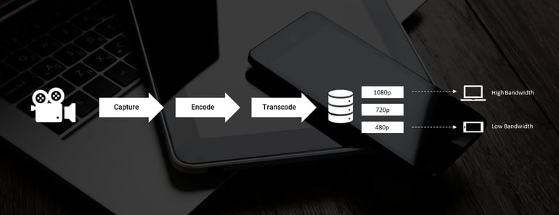

Fig 3.1: Transcode of video streaming

### **BENEFITS OF VIDEO STREAMING**

Video streaming offers the following advantages.

* **Downloading vs. streaming.** Users can view videos without having to download them.
* **High playback resolutions.** Some services support up to 4K, which is a higher quality than the standard for over-the-air TV resolution.
* **Price.** Some video streaming services such as YouTube and Twitch can be used for free, while other streaming services rely on subscription models that may cost less than the average cable subscription.
* **Platform choice.** Users can choose from a number of platforms to stream videos. TV and movie streaming services typically try to compete with one another by making exclusive content. Users can view livestreamed content as it happens, while they can view on-demand content, which is prerecorded media, whenever they want.
* **Content variation.** Since the concept of video streaming is so broad, individuals can stream TV shows, movies, user-generated content from websites like YouTube, or livestream content online.

**3.2: PROJECT CATEGORY**

## ****Video Streaming Technology work:****

The technology of online video streaming is still being perfected. However, the technology that is now available is quite strong and allows for live video streaming. Viewers from all over the world can tune in to a single event without ever leaving their homes.

Here’s what goes behind online video streaming:

1. RAW video is captured by the camera.
2. The encoder receives video from a capture card or another source.
3. RAW footage is converted to a digital form by the encoder.
4. The footage is uploaded to an internet video site.
5. A content delivery network transports the video from the online video platform to the video player.
6. The stream is shown on the viewer's internet-enabled device by the video player.

Music, video, and other forms of media assets are pre-arranged and sent in consecutive data packets so that they may be streamed instantly. Media files, unlike typical downloads that are saved on your device, are instantly removed once they have been played.

Streaming video content distribution may be divided into two categories:

* The viewer may pick what information to watch at any moment with on-demand delivery. Because each player requires a separate network stream, this form of streaming boosts bandwidth expenses. On a regular basis, programmed-time streaming creates a conduit for an audience.

* Media packets must arrive in a timely way for real-time streaming video applications. Packets that are excessively delayed are considered worthless and are viewed as lost. To fulfill time and/or bandwidth limits, streaming technology also expects that some packets would be dropped. The user connection can be tailored to the amount of bandwidth available to the user.

### **Is the User Datagram Protocol (UDP) or the Transmission Control Protocol (TCP) used for streaming?**

UDP is used by some streaming technologies, whereas TCP is used by others. UDP and TCP are both transport protocols, which means they're used to move data packets across networks. Both are used in conjunction with the Internet Protocol (IP). Before transmitting data, TCP establishes a dedicated connection and ensures that all data packets arrive in the correct order. UDP, in contrast to TCP, does neither of these things. As a result, TCP is more reliable, yet data transmission via UDP takes less time than data transmission via TCP, though some packets are lost in the process.

If TCP is analogous to a package delivery service that requires the recipient to sign for the package, UDP is analogous to a package delivery service that puts packages on the front porch without knocking on the door to obtain a signature. TCP delivery loses fewer packages, while UDP delivery is faster because packages can be delivered even if no one is home to sign for them.

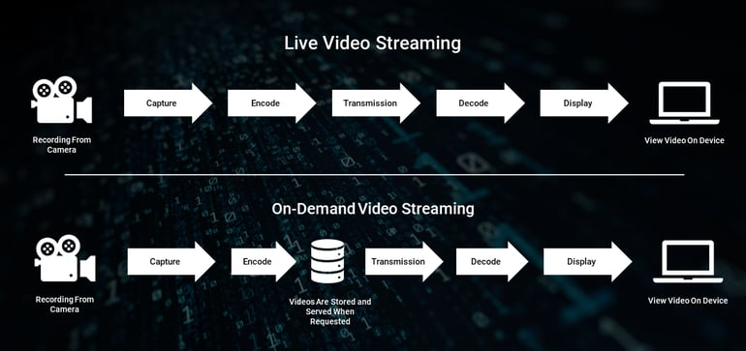

## **Fig 3.2: Pre-encoded video streaming**

To produce a smooth streaming experience, several forms of video streaming technologies are combined.

**3.3: TYPES OF STREAMING**

Streaming protocols, codecs, video players, and content delivery networks are the four primary categories of streaming technology. Each of these essential components works in tandem to send video from one location to another.

### **Streaming Protocols:**

Streaming protocols are standardized ways to send media over the internet. They break down large amounts of data into little portions that may be sent via a variety of internet connections.

Protocols are vital in broadcasting because they transport content from one place to another throughout the video streaming process. For live streaming, there are numerous video streaming protocols to consider. Let's take a look at some of the most popular ones today.

#### **HLS:**

One of the most essential protocols in streaming nowadays is HTTPS Live Streaming (HLS). Apple created this protocol to interact with the HTML5 video player. It's utilized to get material from the content delivery network to the player in front of the user.

HLS may also be used to ingest media from an encoder to an online video platform, but because HLS encoders aren't as common as RTMP encoders, HLS delivery is usually combined with RTMP intake.

#### **RTMP:**

Another key protocol used by broadcasters nowadays is the Real-Time Messaging Protocol (RTMP). This was originally designed to send material to Adobe's Flash player, but with that video player's demise, it has taken on a new function in streaming.

This protocol is currently used for RTMP intake. That is, it sends movies from the encoder to an internet video platform or straight to a content delivery network. Low-latency streaming and inexpensive RTMP encoders are two advantages of RTMP.

#### **RTSP:**

The Real-Time Streaming Protocol (RTSP) is a lesser-known protocol that is crucial. It's commonly mixed up with RTMP, although they're not the same thing. RTSP is a protocol that allows the user to send commands to the video player.

It informs the video player when the user clicks Play, Pause, Fast-Forward, and other in-player controls, for example. RTSP is also useful since it allows users to watch videos before they are entirely downloaded. This improves the viewing experience by eliminating the need for them to wait for their selected material to play.

#### **MPEG-DASH:**

MPEG-DASH is an open-source streaming technology comparable to HLS in form. This standard is notable for being the first to offer adaptive bitrate streaming. This enables viewers to instantly receive a broadcast of the highest quality for their internet connection.

## That way, folks with slower internet won't have to deal with a lot of latency and buffering. MPEG-DASH is commonly associated with streaming protocols, however, it really relies on TCP, which is a separate protocol. This standard is gradually acquiring acceptance from related technology, increasing its compatibility.

### **Codecs:**

When you capture a video with a camera, the RAW video files are made up of hundreds of still frames that combine to create the fluid motion we recognize as video. However, because these files are large, they cannot be streamed.

They must first be transformed into a digital format before they can be streamed. Stills that are duplicates and judged superfluous are thrown out or compressed for transfer in order to convert videos into digital files. The technology that allows this to happen is called a codec, which is a portmanteau for "coder-decoder."

A codec essentially compresses the video files it receives and transmits them from one point in the streaming process to the next. To make it easier for them to go via the internet, they keep their content concise. "Encoders" are the tools that utilize codecs. There are both hardware and software encoders, and we'll go over them in more detail later.

### **Video Players:**

A video player is a piece of user-facing software that allows viewers to watch a video stream. Adobe's Flash player was once the industry standard, but it has now become obsolete due to its incompatibility with mobile streaming

Since then, the HTML5 video player has established itself as the industry standard. Apple created this video player to facilitate mobile video streaming. The HTML5 video player is compatible with virtually any internet-connected device, including smartphones, tablets, smart TVs, and game consoles. HTML5 is also supported by the vast majority of browsers and OS systems. HTML5 video players are extremely safe and configurable, in addition to being ultra-compliant. HTML5 is the standard for most live streaming systems because it provides so many advantages for broadcasters.

### **Content Delivery Networks (CDNs):**

A content delivery network (CDN) is a collection of servers strategically located across a geographic region to provide high-quality material to locations far from the source of the stream. The streaming CDN operates by sending content to a network of servers. Video players connected to the internet video platform allow users to choose the content they want to watch. The CDN will then reroute the request from the originating site's server to a CDN server nearest to the user, which will then deliver the cached material.

Content may be delivered faster by placing servers closer to both the originating point and the destination. Many broadcasters use CDNs through relationships made through their online video platform of choice.

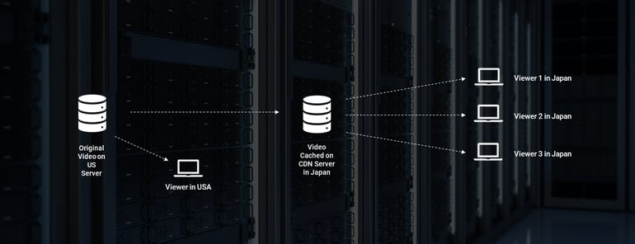

Fig 3.3: Content Delivery Network of video streaming

## **Factors you should consider while selecting a Video Streaming Protocol:**

The choice of video streaming protocol is based on a few important variables that may be unique to a company's requirements. You may want to guarantee that you reach the largest potential audience or that latency is kept to a minimum.

Alternatively, the streams' security and privacy may be more essential to you. Here's a rough strategy for making a decision based on these considerations.

1. If you want your streaming material to reach the biggest potential audience, choose one that is compatible with most devices, platforms, and browsers. In this scenario, HLS is probably the best option, and it can even be set as the default solution when in doubt.
2. Although HLS has the broadest reach for streaming, it is known to cause considerable latency during playback. Although RTMP streams have low latency, they are not compatible with HTML5 video players. WebRTC provides real-time latency whereas SRT provides reduced latency streaming. However, if you choose one of these two, keep in mind that you may be limiting your reach because they aren't as widely supported in the streaming technology market.

1. If the safety of your streams on their route to the end-user is your primary concern, use a protocol that includes security safeguards. Secure streaming is provided by most protocols, including the commonly used HLS standard, however, SRT is the protocol with the finest security and privacy capabilities.

1. Adaptive bitrate, as previously mentioned, enables the best possible video experience regardless of the end-network user's capability, device, or software. If this is a priority for our streaming requirements, HLS and MPEG-DASH are protocols that support it.

1. Last but not least, consider the costs connected with implementing the protocol and whether they are within your budgetary constraints. Protocols that leverage HTTP web servers, such as HLS and MPEG-DASH, are generally more cost-effective than traditional protocols since they eliminate the technical difficulty of development and setup.

**SOURCE CODE**

<?php

session_start();

?>

<!DOCTYPE html>

<html lang="en" dir="ltr">

<head>

<meta charset="utf-8">

<title>AnveshFlix-Account</title>

<link rel="stylesheet" href="homepage.css" type="text/css">

<link rel="stylesheet" href="https://stackpath.bootstrapcdn.com/bootstrap/4.1.3/css/bootstrap.min.css" integrity="sha384-MCw98/SFnGE8fJT3GXwEOngsV7Zt27NXFoaoApmYm81iuXoPkFOJwJ8ERdknLPMO" crossorigin="anonymous">

</head>

<body>

<header>

<nav class="navbar navbar-expand-md navbar-dark bg-dark">

<a href="homepage.php" class="navbar-brand"> <img src="images/logo.png" alt=""> </a>

<span class="navbar-text">AnuFlix</span>

<ul class="navbar-nav">

<li class="nav-item"> <a href="homepage.php" class="nav-link">Home</a> </li>

<li class="nav-item"> <a href="logout.php" class="nav-link">Logout</a> </li>

</ul>

</nav>

</header>

<div class="container">

<?php

include 'dbh.php';

$id = $_SESSION['id'];

$sql = "SELECT * FROM user1 WHERE id = $id ";

$newrecords = mysqli_query($conn,$sql);

$result = mysqli_fetch_assoc($newrecords);

echo" <form action='update.php' method='POST'>

<br><br><input type='text' class='form-control' placeholder='Enter full name' name='fname' value='".ucwords($result['name'])."'>

<br>

<input type='text' class='form-control' placeholder='Enter mobile number' name='phn' value='".$result['phone']."'>

<br>

<label><b>Date of Birth : </b></label>

<input type='text' class='from-control' placeholder='Enter Date of Birth' name='dob' value='".$result['DOB']."'><br>

<div class='signupbutton'>

<br><br>

<button type='submit' class='btn btn-success' name='sub' value='submit'>Update Details</button>

</div>

</form>

<br><br>

<label><b>Email Id : </b>".$result['email']."</label>

<br><br>

<a href='accountp.php'>Change Password</a>

";

?>

</div>

</body>

</html>

<?php

session_start();

?>

<!DOCTYPE html>

<html lang="en" dir="ltr">

<head>

<meta charset="utf-8">

<title>AnveshFlix-Account</title>

<link rel="stylesheet" href="homepage.css" type="text/css">

<link rel="stylesheet" href="https://stackpath.bootstrapcdn.com/bootstrap/4.1.3/css/bootstrap.min.css" integrity="sha384-MCw98/SFnGE8fJT3GXwEOngsV7Zt27NXFoaoApmYm81iuXoPkFOJwJ8ERdknLPMO" crossorigin="anonymous">

</head>

<body>

<header>

<nav class="navbar navbar-expand-md navbar-dark bg-dark">

<a href="homepage.php" class="navbar-brand"> <img src="images/logo.png" alt=""> </a>

<span class="navbar-text">AnveshFlix</span>

<ul class="navbar-nav">

<li class="nav-item"> <a href="homepage.php" class="nav-link">Home</a> </li>

<li class="nav-item"> <a href="logout.php" class="nav-link">Logout</a> </li>

</ul>

</nav>

</header>

<div class="container">

<?php

include 'dbh.php';

$id = $_SESSION['id'];

$sql = "SELECT * FROM user1 WHERE id = $id ";

$newrecords = mysqli_query($conn,$sql);

$result = mysqli_fetch_assoc($newrecords);

echo" <form action='update.php' method='POST'>

<br><br><input type='text' class='form-control' placeholder='Enter full name' name='fname' value='".ucwords($result['name'])."'>

<br>

<input type='text' class='form-control' placeholder='Enter mobile number' name='phn' value='".$result['phone']."'>

<br>

<label><b>Date of Birth : </b></label>

<input type='text' class='from-control' placeholder='Enter Date of Birth' name='dob' value='".$result['DOB']."'><br>

<div class='signupbutton'>

<br><br>

<button type='submit' class='btn btn-success' name='sub' value='submit'>Update Details</button>

</div>

</form>

<br><br>

<label><b>Email Id : </b>".$result['email']."</label>

<br><br>

<form class='' action='updatep.php' method='post'>

<input type='password' class='form-control' placeholder='Enter old password' name='oldp'><br>

<input type='password' class='form-control' placeholder='Enter new password' name='newp'><br>

<button type='submit' class='btn btn-success ' name='subpass' value='submit'>Update Password</button><br>

</form>

";

?>

</div>

</body>

</html>

<?php

session_start();

?>

<!DOCTYPE html>

<head>

<meta charset="utf-8">

<title>NeonFlix-Admin</title>

<link rel="stylesheet" href="user.css" type="text/css">

<link rel="stylesheet" href="https://stackpath.bootstrapcdn.com/bootstrap/4.1.3/css/bootstrap.min.css" integrity="sha384-MCw98/SFnGE8fJT3GXwEOngsV7Zt27NXFoaoApmYm81iuXoPkFOJwJ8ERdknLPMO" crossorigin="anonymous">

</head>

<body>

<header>

<div class="container-fluid">

<nav class="navbar navbar-expand-md navbar-dark bg-dark">

<a href="homepage.php" class="navbar-brand"> <img src="images/logo.png" alt=""> </a>

<span class="navbar-text">NeonFlix</span>

<ul class="navbar-nav">

<li class="nav-item"> <a href="homepage.php" class="nav-link"> Home </a> </li>

<li class="nav-item"> <a href="logout.php" class="nav-link"> Logout</a> </li>

</ul>

</nav>

<div class="container">

<div class="jumbotron">

<h1> Enter the Movie details</h1>

<p> <b></b> </p> <br>

<form class="" action="admin-control.php" method="POST" enctype="multipart/form-data">

<input type="text" class="form-control" placeholder="Movie Name" name="mname" value=""><br>

<input type="text" class="form-control" placeholder="Year of Release" name="release" value="">

<br>

<input type="text" class="form-control" placeholder="Genre" name="genre" value="">

<br>

<input type="number" class="form-control" placeholder="Runtime in minutes" name="rtime" value="">

<br>

<input type="text" class="form-control" placeholder="Description..." name="desc" value="">

<br>

<div class="row">

<div class="col">

<table>

<tr>

<td> <label for=""><b>Upload Image : </b></label> </td>

<td>

<div class="">

<input type="hidden" name="size" value="100000">

<input type="file" name="image" value="">

</div>

</td>

</tr>

</table>

</div>

<div class="col">

<table>

<tr>

<td> <label for=""><b>Upload Video : </b></label> </td>

<td>

<div class="">

<input type="hidden" name="size" value="30000000">

<input type="file" name="video" value="">

</div>

</td>

</tr>

</table>

</div>

</div> <br><br>

<div class="signupbutton">

<input type="submit" class ="btn btn-success btn-lg" name="upload" value="Submit" >

</div>

</form>

</div>

</div>

</div>

</div>

</header>

<footer class="page-footer font-small blue">

<div class="footer-copyright text-center py-3">© 2018 Copyright:

<a href="">chenna.anveshkumar143414@gmail.com</a>

</div>

</footer>

</body>

</html>

<?php

session_start();

if (isset($_POST['upload'])) {

include 'dbh.php';

$targetvid = "video-uploads/".basename($_FILES['video']['name']);

$target = "uploads/".basename($_FILES['image']['name']);

$name = strtolower($_POST['mname']);

$rdate = $_POST['release'];

$genre = strtolower($_POST['genre']);

$rtime = $_POST['rtime'];

$desc = $_POST['desc'];

$image = $_FILES['image']['name'];

$video = $_FILES['video']['name'];

$sql = "INSERT INTO movies (name, rdate, genre, runtime, decription, imgpath, videopath)

VALUES('$name','$rdate','$genre','$rtime','$desc','$image','$video')";

mysqli_query($conn,$sql);

if (move_uploaded_file($_FILES['image']['tmp_name'],$target) && move_uploaded_file($_FILES['video']['tmp_name'],$targetvid)) {

header("Location: homepage.php");

}else {

echo "error uploading";

}

}

?>

<?php

$conn = mysqli_connect("localhost","root","","sourcecodester_omsdb");

if(! $conn ) {

die('Could not connect: ' . mysqli_error());

}

?>

<?php

include 'dbh.php';

$im = "SELECT * FROM movies ORDER BY name ASC" ;

$records = mysqli_query($conn,$im);

start:

$i=0;

echo"<div class='row'>";

while($result = mysqli_fetch_assoc($records)){

echo"<form action='movie.php' method='POST'>";

echo"<div class='col'>";

echo "<img src='uploads/".$result['imgpath']."' height='250' width='200' style='margin-top: 30px;margin-left:30px;margin-right:20px;' />";

echo"<div class='noob'>";

echo "<input type='submit' name='submit' class='btn btn-outline-info' style='display:block;width:200px;padding-bottom:15px;margin-bottom:30px;margin-left:30px;margin-right:20px;' value='".ucwords($result['name'])."'/>";

echo"</div>";

echo"</div>";

echo"</form>";

if ($i==4) {

echo"</div>";

goto start;

}

$i++;

}

echo"</div>";

?>

body{

font-family: sans-serif;

height: 100%;

}

.navbar-text{

font-size: 30px;

font-weight: bold;

}

.navbar li{

padding: 0 40px;

}

.nav-item a{

text-decoration: none;

color: white;

font-size: 25px;

}

.navbar span{

font-size: 25px;

}

.nav-item a:hover{

color: orange;

border-bottom: 2px solid orange;

}

.navbar-brand img{

height: 80px;

}

.container-fluid{

background-image: url(images/back.jpg);

height: 50vh;

background-position: center;

background-size: cover;

background-attachment: fixed;

text-align: center;

border: 2px solid grey;

}

.container-fluid h1{

color: white;

}

.page-footer{

background-color: black;

color: white;

}

.col a{

text-align: center;

}

<?php

session_start();

?>

<!DOCTYPE html>

<html lang="en" dir="ltr">

<head>

<meta charset="utf-8">

<title>AnveshFlix-Homepage</title>

<link rel="stylesheet" href="homepage.css" type="text/css">

<link rel="stylesheet" href="https://stackpath.bootstrapcdn.com/bootstrap/4.1.3/css/bootstrap.min.css" integrity="sha384-MCw98/SFnGE8fJT3GXwEOngsV7Zt27NXFoaoApmYm81iuXoPkFOJwJ8ERdknLPMO" crossorigin="anonymous">

</head>

<body>

<header>

<nav class="navbar navbar-expand-md navbar-dark bg-dark">

<a href="#" class="navbar-brand"> <img src="images/logo.png" alt=""> </a>

<span class="navbar-text">AnveshFlix</span>

<ul class="navbar-nav">

<?php

if (isset($_SESSION['id'])) {

if ($_SESSION['id'] == 1) {

echo "<li class='nav-item'> <a href='admin.php' class='nav-link'>Add movie</a> </li>";

}

}

echo"<li class='nav-item'> <a href='account.php' class='nav-link'>Account</a> </li>

<li class='nav-item'> <a href='logout.php' class='nav-link'>Logout</a> </li>

</ul>

</nav>

<div class='container-fluid'>

<br><br><br>";

include 'dbh.php';

$id = $_SESSION['id'];

$quer = "SELECT * FROM user1 WHERE id = '$id' ";

$quer2 = "SELECT * FROM movies WHERE mid in (SELECT mid from user1 where id = '$id') ";

$check = mysqli_query($conn,$quer);

$rel = mysqli_fetch_assoc($check);

$check2 = mysqli_query($conn,$quer2);

$rel2 = mysqli_fetch_assoc($check2);

echo"<h1 style='color:black;position:sticky;'>WELCOME </h1><b style = 'color: black;font-size: 25px'><i> ".ucwords($rel['name'])." !</i></b>

</div>

</header>

<section>

<div class='jumbotron' style='margin-top:15px;padding-top:30px;padding-bottom:30px;'>

<div class='row'>

<div class='col'>

<form action='movie.php' method='POST'>

<h4 style='color:black;font-size:30px;'>Recent :

<input type='submit' name='submit' class='btn btn-success' style='display:inline;width:200px;margin-left:20px;margin-right:20px;' value='".ucwords($rel2['name'])."'/></h4>

</form>

</div>

<div class='col'>

<form action='search.php' method='POST'>

<select name='option' style='padding:5px;'>

<option selected>Search By</option>

<option value='name'>Name</option>

<option value='genre'>Genre</option>

<option value='rdate'>Release year</option>

</select>

<input type='text' placeholder='Enter..' style='margin-left:10px;margin-top:10px;padding:5px;' name='textoption'>

<input type='submit' name='submit' class='btn btn-success' style='display:inline;width:100px;margin-left:20px;margin-right:20px;margin-top:5px;' value='Search'/></h4>

</form>

</div>

</div>

</div>";

?>

<div class="jumbotron">

<h2 style='margin-top:0px;padding-top:0px;'>Latest updated</h2>

<div class="row">

<?php

include 'latest-fetcher.php';

?>

</div>

</div>

<div class="jumbotron">

<h2> All movies</h2>

<?php

include 'fetcher.php';

?>

</div>

</section>

<footer class="page-footer font-small blue">

<div class="footer-copyright text-center py-3">© 2018 Copyright:

<a href="">chenna.anveshkumar143414@gmail.com</a>

</div>

</footer>

</body>

</html>

<?php

include 'login.php';

?>

<?php

include 'dbh.php';

$im = "SELECT * FROM movies" ;

$records = mysqli_query($conn,$im);

$count = mysqli_num_rows($records);

$i=$count;

$j=$count-3;

$newim = "SELECT * FROM movies WHERE mid BETWEEN '$j' AND '$i'" ;

$newrecords = mysqli_query($conn,$newim);

while($fetchr = mysqli_fetch_assoc($newrecords)){

echo"<form action='movie.php' method='POST'>";

echo"<div class='col'>";

echo "<img src='uploads/".$fetchr['imgpath']."' height='250' width='200' style='margin-top: 30px;margin-left:50px;margin-right:20px;' />";

echo"<div class='noob'>";

echo "<input type='submit' name='submit' class='btn btn-outline-info' style='display:block;width:200px;padding-bottom:15px;margin-bottom:30px;margin-left:50px;margin-right:20px;' value='".ucwords($fetchr['name'])."'/>";

echo"</div>";

echo"</div>";

echo"</form>";

}

?>

<?php

session_start();

?>

<!DOCTYPE html>

<html lang="en" dir="ltr">

<head>

<meta charset="utf-8">

<title>AnuFlix</title>

<link rel="stylesheet" href="master.css" type="text/css">

<link rel="stylesheet" href="https://stackpath.bootstrapcdn.com/bootstrap/4.1.3/css/bootstrap.min.css" integrity="sha384-MCw98/SFnGE8fJT3GXwEOngsV7Zt27NXFoaoApmYm81iuXoPkFOJwJ8ERdknLPMO" crossorigin="anonymous">

</head>

<body>

<header>

<div class="container-fluid">

<nav class="navbar navbar-expand-md navbar-dark bg-dark ">

<a href="login.php" class="navbar-brand"> <img src="images/logo.png" alt=""> </a>

<span class="navbar-text">NeonFlix</span>

<ul class="navbar-nav">

<li class="nav-item"> <a href="#A" class="nav-link"> Services</a> </li>

<li class="nav-item"> <a href="user-login.php" class="nav-link"> SignIn</a> </li>

</ul>

</nav>

<div class="container">

<div class="jumbotron">

<h1>Watch Anywhere, <br> Watch Anytime... </h1> <br>

<a href="test.php" type="button" class="btn btn-danger btn-block">Sign Up Now</a>

</div>

</div>

</div>

</header>

<section class="features">

<a href="#" name="A"></a>

<h2>Our Services</h2>

<div class="container">

<div class="row">

<div class="col-md-4">

<p class="arrange"><img src="images/mob.png" alt=""> <br> Lorem ipsum dolor sit amet, consectetur adipisicing elit, sed do eiusmod tempor incididunt ut labore et dolore magna aliqua. Ut enim ad minim veniam, quis nostrud exercitation ullamco laboris nisi ut aliquip ex ea commodo consequat. Duis aute irure dolor in reprehenderit in voluptate velit esse cillum dolore eu fugiat nulla pariatur. Excepteur sint occaecat cupidatat non proident, sunt in culpa qui officia deserunt mollit anim id est laborum.

</p>

</div><div class="col-md-4">

<p class="arrange"><img src="images/mess.png" alt=""> <br> Lorem ipsum dolor sit amet, consectetur adipisicing elit, sed do eiusmod tempor incididunt ut labore et dolore magna aliqua. Ut enim ad minim veniam, quis nostrud exercitation ullamco laboris nisi ut aliquip ex ea commodo consequat. Duis aute irure dolor in reprehenderit in voluptate velit esse cillum dolore eu fugiat nulla pariatur. Excepteur sint occaecat cupidatat non proident, sunt in culpa qui officia deserunt mollit anim id est laborum.

</p>

</div>

<div class="col-md-4">

<p class="arrange">

<img src="images/desktop.jpg"> <br> Lorem ipsum dolor sit amet, consectetur adipisicing elit, sed do eiusmod tempor incididunt ut labore et dolore magna aliqua. Ut enim ad minim veniam, quis nostrud exercitation ullamco laboris nisi ut aliquip ex ea commodo consequat. Duis aute irure dolor in reprehenderit in voluptate velit esse cillum dolore eu fugiat nulla pariatur. Excepteur sint occaecat cupidatat non proident, sunt in culpa qui officia deserunt mollit anim id est laborum.

</p>

</div>

</div>

</div>

<h3></h3>

</section>

<footer class="page-footer font-small blue">

<div class="footer-copyright text-center py-3">© 2018 Copyright:

<a href="">chenna.anveshkumar143414@gmail.com</a>

</div>

</footer>

</body>

</html>

<?php

session_start();

session_destroy();

header("Location: login.php");

?>

body{

font-family: sans-serif;

height: 100%;

}

.navbar-text{

font-size: 30px;

font-weight: bold;

}

.navbar li{

padding: 0 40px;

}

.nav-item a{

text-decoration: none;

color: white;

font-size: 25px;

}

.nav-item a:hover{

color: orange;

border-bottom: 2px solid orange;

}

.jumbotron{

position: inherit;

margin-top: 20%;

}

.jumbotron h1{

color: black;

font-weight: bold;

text-align: center;

}

h2:after{

width: 150px;

height: 2px;

background-color: orange;

display: block;

content: "";

margin: 0 auto;

margin-top: 50px;

}

.features h2{

margin-top: 60px;

text-align: center;

font-size: 40px;

font-weight: bold;

}

.container-fluid{

background-image: linear-gradient(rgba(0, 0, 0, 0.2), rgba(0,0,0,0.2)),url(images/back.jpg);

height: 130vh;

background-position: center;

background-size: cover;

background-attachment: fixed;

}

.navbar-brand img{

height: 80px;

}

.features p{

margin-top: 20%;

width: 70%;

margin-left: 15%;

}

.arrange{

text-align: justify;

}

.row img{

height: 60px;

width: 60px;

margin-left: 40%;

margin-bottom: 20%;

}

.page-footer{

background-color: black;

color: white;

}

body{

background-color: black;

}

.jumbotron-fluid{

background-color: #2d2f33;

color: #e2dd31;

margin-left: 2%;

margin-right: 2%;

height: 150vh;

}

.jumbotron-fluid h1:hover{

color: #85c639;

}

.jumbotron-fluid h4:hover{

color: #85c639;

}

.jumbotron-fluid h5{

color:#9e8b24;

}

.container video{

margin-left: 2%;

}

.page-footer{

background-color: black;

color: white;

}

<?php

session_start();

if (isset($_POST['submit'])) {

$title = $_POST['submit'];

include 'dbh.php';

$im = "SELECT * FROM movies WHERE name = '$title'" ;

$records = mysqli_query($conn,$im);

echo"<!DOCTYPE html>";

echo"<html lang='en' dir='ltr'>";

echo"<head>";

echo"<meta charset='utf-8'>";

echo"<title>".$title."</title>";

echo"<link rel='stylesheet' href='movie.css'>";

echo"<link rel='stylesheet' href='https://stackpath.bootstrapcdn.com/bootstrap/4.1.3/css/bootstrap.min.css' integrity='sha384-MCw98/SFnGE8fJT3GXwEOngsV7Zt27NXFoaoApmYm81iuXoPkFOJwJ8ERdknLPMO' crossorigin='anonymous'>";

echo"</head>";

echo"<body>";

echo"<div class='jumbotron-fluid'>";

echo"<div class='container'>";

while($result = mysqli_fetch_assoc($records)){

$mname = $result['name'];

$person = $_SESSION['id'];

$movieid = $result['mid'];

$current = $result['viewers'];

$newcount = $current + 1;

$newsql = "UPDATE movies SET viewers = '$newcount' WHERE name='$mname' ";

$nsql = "UPDATE user1 SET mid = '$movieid'";

$updatecount = mysqli_query($conn,$newsql);

$updatecount = mysqli_query($conn,$nsql);

$url ="video-uploads/".$result['videopath'];

echo"<br>";

echo"<a href='homepage.php' style='font-size: 20px;color:orange;border:1px solid orange;border-radius:5px;padding:10px;text-decoration:none;'>Back to Home </a>";

echo "<br><br><h5 style='display: inline;'><br>movie name : </h5><h1 style='display: inline;'>".ucwords($result['name'])."</h1>";

echo"<br><h5 style='display: inline;' >genre : </h5><h4 style='display: inline;'>".ucwords($result['genre'])."</h4>";

echo"<br><h5 style='display: inline;' >release year : </h5><h4 style='display: inline;'>".$result['rdate']."</h4>";

echo"<br><h5 style='display: inline;' >description : </h5><h4 style='display: inline;'>".ucfirst($result['decription'])."</h4>";

echo"<br><h5 style='display: inline;' >runtime : </h5><h4 style='display: inline;'>".$result['runtime']." mins </h4>";

echo"<br><h5 style='display: inline;' >views : </h5><h4 style='display: inline;'>".$result['viewers']."</h4>";

echo"<br><br><br>";

echo"<div class='embed-responsive embed-responsive-16by9'>";

echo '<video controls="controls" class="embed-responsive-item">

<source src="'.$url.'" type="video/mp4">

Your browser does not support the HTML5 Video element.

</video>

';

echo"</div>";

}

echo"</div>";

echo"</div>";

echo"</body>";

echo"</html>";

}

?>

<?php

session_start();

include 'dbh.php';

$username = $_POST['mail'];

$password = $_POST['pass'];

$sql = "SELECT * FROM user1 WHERE username = '$username' AND passwd = '$password' ";

$result = $conn->query($sql);

if(!$row = $result->fetch_assoc()) {

echo "incorrect username or password";

}else {

$_SESSION['id'] = $row['id'];

header("Location: homepage.php");

}

?>

<?php

session_start();

?>

<!DOCTYPE html>

<html lang="en" dir="ltr">

<head>

<meta charset="utf-8">

<title>AnuFlix-Homepage</title>

<link rel="stylesheet" href="homepage.css" type="text/css">

<link rel="stylesheet" href="https://stackpath.bootstrapcdn.com/bootstrap/4.1.3/css/bootstrap.min.css" integrity="sha384-MCw98/SFnGE8fJT3GXwEOngsV7Zt27NXFoaoApmYm81iuXoPkFOJwJ8ERdknLPMO" crossorigin="anonymous">

</head>

<body>

<header>

<nav class="navbar navbar-expand-md navbar-dark bg-dark">

<a href="homepage.php" class="navbar-brand"> <img src="images/logo.png" alt=""> </a>

<span class="navbar-text">AnuFlix</span>

<ul class="navbar-nav">

<?php

if (isset($_SESSION['id'])) {

if ($_SESSION['id'] == 1) {

echo "<li class='nav-item'> <a href='admin.php' class='nav-link'>Add movie</a> </li>";

}

}

echo"<li class='nav-item'> <a href='account.php' class='nav-link'>Account</a> </li>

<li class='nav-item'> <a href='logout.php' class='nav-link'>Logout</a> </li>

</ul>

</nav>

<div class='container-fluid'>

<br><br><br>";

include 'dbh.php';

$id = $_SESSION['id'];

$quer = "SELECT * FROM user1 WHERE id = '$id' ";

$quer2 = "SELECT * FROM movies WHERE mid in (SELECT mid from user1 where id = '$id') ";

$check = mysqli_query($conn,$quer);

$rel = mysqli_fetch_assoc($check);

$check2 = mysqli_query($conn,$quer2);

$rel2 = mysqli_fetch_assoc($check2);

echo"<h1>WELCOME </h1><i style = 'color: white;font-size: 25px'> ".ucwords($rel['name'])." !</i>

</div>

</header>

<section>

<div class='jumbotron' style='margin-top:15px;padding-top:30px;padding-bottom:30px;'>

<div class='row'>

<div class='col'>

<form action='movie.php' method='POST'>

<h4 style='color:black;font-size:30px;'>Recent :

<input type='submit' name='submit' class='btn btn-success' style='display:inline;width:200px;margin-left:20px;margin-right:20px;' value='".ucwords($rel2['name'])."'/></h4>

</form>

</div>

<div class='col'>

<form action='search.php' method='POST'>

<select name='option' style='padding:5px;'>

<option selected>Search By</option>

<option value='1'>Name</option>

<option value='2'>Genre</option>

<option value='3'>Release year</option>

</select>

<input type='text' placeholder='Enter..' name='textoption' style='margin-left:10px;margin-top:10px;padding:5px;'>

<input type='submit' name='submit' class='btn btn-success' style='display:inline;width:100px;margin-left:20px;margin-right:20px;margin-top:5px;' value='Search'/></h4>

</form>

</div>

</div>

</div>";

?>

<div class="jumbotron">

<h2 style='margin-top:0px;padding-top:0px;'>Results : </h2>

<?php

include 'searchback.php';

?>

</div>

</section>

<footer class="page-footer font-small blue">

<div class="footer-copyright text-center py-3">© 2018 Copyright:

<a href="">chenna.anveshkumar143414@gmail.com</a>

</div>

</footer>

</body>

</html>

<?php

include 'dbh.php';

if(isset($_POST['submit'])){

$option = $_POST['option'];

$text = strtolower($_POST['textoption']);

$person = $_SESSION['id'];

$found = "SELECT * FROM movies WHERE $option LIKE '$text%'";

$display = mysqli_query($conn,$found);

start:

$i=0;

echo"<div class='row'>";

while($final = mysqli_fetch_assoc($display)){

echo"<form action='movie.php' method='POST'>";

echo"<div class='col'>";

echo "<img src='uploads/".$final['imgpath']."' height='250' width='200' style='margin-top: 30px;margin-left:30px;margin-right:20px;' />";

echo"<div class='noob'>";

echo "<input type='submit' name='submit' class='btn btn-outline-info' style='display:block;width:200px;padding-bottom:15px;margin-bottom:30px;margin-left:30px;margin-right:20px;' value='".ucwords($final['name'])."'/>";

echo"</div>";

echo"</div>";

echo"</form>";

if ($i==4) {

echo"</div>";

goto start;

}

$i++;

}

echo"</div>";

}

?>

-- phpMyAdmin SQL Dump

-- version 4.8.4

-- https://www.phpmyadmin.net/

--

-- Host: 127.0.0.1

-- Generation Time: Dec 20, 2020 at 02:08 PM

-- Server version: 10.1.37-MariaDB

-- PHP Version: 5.6.39

SET SQL_MODE = "NO_AUTO_VALUE_ON_ZERO";

SET AUTOCOMMIT = 0;

START TRANSACTION;

SET time_zone = "+00:00";

/*!40101 SET @OLD_CHARACTER_SET_CLIENT=@@CHARACTER_SET_CLIENT */;

/*!40101 SET @OLD_CHARACTER_SET_RESULTS=@@CHARACTER_SET_RESULTS */;

/*!40101 SET @OLD_COLLATION_CONNECTION=@@COLLATION_CONNECTION */;

/*!40101 SET NAMES utf8mb4 */;

--

-- Database: `sourcecodester_omsdb`

--

-- --------------------------------------------------------

--

-- Table structure for table `movies`

--

CREATE TABLE `movies` (

`mid` int(10) NOT NULL,

`name` varchar(30) NOT NULL,

`genre` varchar(20) NOT NULL,

`rdate` varchar(5) NOT NULL,

`runtime` varchar(4) NOT NULL,

`decription` varchar(100) NOT NULL,

`viewers` int(10) DEFAULT '1',

`imgpath` text NOT NULL,

`videopath` text NOT NULL

) ENGINE=InnoDB DEFAULT CHARSET=latin1;

--

-- Dumping data for table `movies`

--

INSERT INTO `movies` (`mid`, `name`, `genre`, `rdate`, `runtime`, `decription`, `viewers`, `imgpath`, `videopath`) VALUES

(1, 'rampage', 'fiction', '2017', '120', 'animals', 8, 'rampage.jpg', 'RAMPAGE Trailer.mp4'),

(2, 'black panther', 'fiction', '2017', '140', 'super hero movie', 13, 'black panther.jpg', 'Black Panther.mp4'),

(3, 'spiderman homecoming', 'fiction', '2018', '110', 'super hero movie', 5, 'spider-man-homecoming.jpg', 'Spider-Man Homecoming.mp4'),

(4, 'jumanji', 'adventure', '2017', '130', '4 kids stuck in video game', 12, 'jumanji2017.jpg', 'JUMANJI 17.mp4'),

(5, 'the conjuring', 'horror', '2013', '120', 'ghost house', 1, 'Conjuring.jpg', 'The Conjuring.mp4'),

(6, 'the conjuring 2', 'horror', '2015', '115', 'cursed family', 1, 'conjuring2.jpg', 'The Conjuring 2.mp4'),

(7, 'infinity wars ', 'fiction', '2018', '123', 'collaboration of all marvel characters', 5, 'infinity war.jpg', 'Avengers Infinity War.mp4'),

(8, 's', 's', 's', '', 's', 27, 'Baby Care Website in PHP with Full Source Code.jpg', ''),

(9, 's', 's', 's', '12', 'sd', 27, 'Online Attendance Management System in PHP with Full Source Code.jpg', 'Attendance Monitoring.mp4'),

(10, 'sadasdas', 'asd', 'asd', '', 'asd', 19, 'Attendance Monitoring System in Android with Full Source Code.jpg', 'Attendance Monitoring.mp4');

-- --------------------------------------------------------

--

-- Table structure for table `rating`

--

CREATE TABLE `rating` (

`rating_id` int(10) NOT NULL,

`mid` int(11) DEFAULT NULL,

`id` int(11) DEFAULT NULL,

`rate_count` int(3) NOT NULL

) ENGINE=InnoDB DEFAULT CHARSET=latin1;

-- --------------------------------------------------------

--

-- Table structure for table `user1`

--

CREATE TABLE `user1` (

`id` int(100) NOT NULL,

`username` varchar(25) NOT NULL,

`passwd` varchar(20) NOT NULL,

`name` varchar(20) NOT NULL,

`phone` varchar(10) NOT NULL,

`email` varchar(25) NOT NULL,

`DOB` varchar(10) NOT NULL,

`mid` int(11) DEFAULT NULL

) ENGINE=InnoDB DEFAULT CHARSET=latin1;

--

-- Dumping data for table `user1`

--

INSERT INTO `user1` (`id`, `username`, `passwd`, `name`, `phone`, `email`, `DOB`, `mid`) VALUES

(1, 'admin@gmail.com', 'admin', 'shubham belgaonkar', '8692849041', 'shubhamb756@gmail.com', '25/04/1998', 7),

(4, 'soubik@gmail.com', '1234', 'soubik bera', '8622849041', 'soubik@gmail.com', '16/10/1995', 7),

(5, 'niru@gmail.com', '1234', 'niru lal', '1234287564', 'niru@gmail.com', '16/09/1996', 7),

(6, 'janobe@gmail.com', 'admin', 's s', '9876565421', 'janobe@gmail.com', '15/01/1995', 7);

--

-- Indexes for dumped tables

--

--

-- Indexes for table `movies`

--

ALTER TABLE `movies`

ADD PRIMARY KEY (`mid`);

--

-- Indexes for table `rating`

--

ALTER TABLE `rating`

ADD PRIMARY KEY (`rating_id`),

ADD KEY `mid` (`mid`),

ADD KEY `id` (`id`);

--

-- Indexes for table `user1`

--

ALTER TABLE `user1`

ADD PRIMARY KEY (`id`),

ADD UNIQUE KEY `username` (`username`),

ADD KEY `mid` (`mid`);

--

-- AUTO_INCREMENT for dumped tables

--

--

-- AUTO_INCREMENT for table `movies`

--

ALTER TABLE `movies`

MODIFY `mid` int(10) NOT NULL AUTO_INCREMENT, AUTO_INCREMENT=11;

--

-- AUTO_INCREMENT for table `rating`

--

ALTER TABLE `rating`

MODIFY `rating_id` int(10) NOT NULL AUTO_INCREMENT;

--

-- AUTO_INCREMENT for table `user1`

--

ALTER TABLE `user1`

MODIFY `id` int(100) NOT NULL AUTO_INCREMENT, AUTO_INCREMENT=7;

--

-- Constraints for dumped tables

--

--

-- Constraints for table `user1`

--

ALTER TABLE `user1`

ADD CONSTRAINT `user1_ibfk_1` FOREIGN KEY (`mid`) REFERENCES `movies` (`mid`);

COMMIT;

/*!40101 SET CHARACTER_SET_CLIENT=@OLD_CHARACTER_SET_CLIENT */;

/*!40101 SET CHARACTER_SET_RESULTS=@OLD_CHARACTER_SET_RESULTS */;

/*!40101 SET COLLATION_CONNECTION=@OLD_COLLATION_CONNECTION */;

<?php

session_start();

?>

<!DOCTYPE html>

<head>

<meta charset="utf-8">

<title>Registration</title>

<link rel="stylesheet" href="user.css" type="text/css">

<link rel="stylesheet" href="https://stackpath.bootstrapcdn.com/bootstrap/4.1.3/css/bootstrap.min.css" integrity="sha384-MCw98/SFnGE8fJT3GXwEOngsV7Zt27NXFoaoApmYm81iuXoPkFOJwJ8ERdknLPMO" crossorigin="anonymous">

</head>

<body>

<header>

<div class="container-fluid">

<nav class="navbar navbar-expand-md navbar-dark bg-dark">

<a href="login.php" class="navbar-brand"> <img src="images/logo.png" alt=""> </a>

<span class="navbar-text">NeonFlix</span>

<ul class="navbar-nav">

<li class="nav-item"> <a href="user-login.php" class="nav-link"> SignIn</a> </li>

</ul>

</nav>

<div class="container">

<div class="jumbotron">

<h1>Create an account</h1>

<p>It's free and always will be. </p> <br>

<form class="" action="user.php" method="POST">

<div class="row">

<div class="col">

<input type="text" class="form-control" placeholder="First Name" name="fname" value="">

</div>

<div class="col">

<input type="text" class="form-control" placeholder="Last Name" name="lname" value="">

</div>

</div> <br>

<input type="text" class="form-control" placeholder="Mobile Number" name="phn" value="">

<br>

<input type="email" class="form-control" placeholder="Email Address" name="mail" value="">

<br>

<input type="password" class="form-control" placeholder="Password" name="pass" value="">

<div class="form-group col-md-8" >

<label for="dob"> <br> Birthday </label>

<div class="row">

<div class="col">

<select class="form-control" name='date'>

<option selected>Date..</option>

<option value='1'>1</option>

<option value='2'>2</option>

<option value='3'>3</option>

<option value='4'>4</option>

<option value='5'>5</option>

<option value='6'>6</option>

<option value='7'>7</option>

<option value='8'>8</option>

<option value='9'>9</option>

<option value='10'>10</option>

<option value='11'>11</option>

<option value='12'>12</option>

<option value='13'>13</option>

<option value='14'>14</option>

<option value='15'>15</option>

<option value='16'>16</option>

<option value='17'>17</option>

<option value='18'>18</option>

<option value='19'>19</option>

<option value='20'>20</option>

<option value='21'>21</option>

<option value='22'>22</option>

<option value='23'>23</option>

<option value='24'>24</option>

<option value='25'>25</option>

<option value='26'>26</option>

<option value='27'>27</option>

<option value='28'>28</option>

<option value='29'>29</option>

<option value='30'>30</option>

<option value='31'>31</option>

</select>

</div>

<div class="col">

<select class="form-control" name='month'>

<option selected>month...</option>

<option value='01'>Jan</option>

<option value='02'>Feb</option>

<option value='03'>Mar</option>

<option value='04'>Apr</option>

<option value='05'>May</option>

<option value='06'>Jun</option>

<option value='07'>Jul</option>

<option value='08'>Aug</option>

<option value='09'>Sep</option>

<option value='10'>Oct</option>

<option value='11'>Nov</option>

<option value='12'>Dec</option>

</select>

</div>

<div class="col">

<select class="form-control" name='year'>

<option selected>year...</option>

<option value='1980'>1980</option>

<option value='1981'>1981</option>

<option value='1982'>1982</option>

<option value='1983'>1983</option>

<option value='1984'>1984</option>

<option value='1985'>1985</option>

<option value='1986'>1986</option>

<option value='1987'>1987</option>

<option value='1988'>1988</option>

<option value='1989'>1989</option>

<option value='1990'>1990</option>

<option value='1991'>1991</option>

<option value='1992'>1992</option>

<option value='1993'>1993</option>

<option value='1994'>1994</option>

<option value='1995'>1995</option>

<option value='1996'>1996</option>

<option value='1997'>1997</option>

<option value='1998'>1998</option>

<option value='1999'>1999</option>

<option value='2000'>2000</option>

<option value='2001'>2001</option>

<option value='2002'>2002</option>

<option value='2003'>2003</option>

<option value='2004'>2004</option>

<option value='2005'>2005</option>

<option value='2006'>2006</option>

<option value='2007'>2007</option>

<option value='2008'>2008</option>

<option value='2009'>2009</option>

<option value='2010'>2010</option>

<option value='2011'>2011</option>

<option value='2012'>2012</option>

</select>

</div>

</div>

</div>

<div class="signupbutton">

<br><br>

<button type="submit" class="btn btn-success btn-lg" name="sub" value="submit">Sign Up</button>

</div>

</div>

</form>

</div>

</div>

</div>

</header>

<footer class="page-footer font-small blue">

<div class="footer-copyright text-center py-3">© 2018 Copyright:

<a href="">shubhamb756@gmail.com</a>

</div>

</footer>

</body>

</html>

<?php

session_start();

include 'dbh.php';

if(isset($_POST['sub'])){

$nam = strtolower($_POST['fname']);

$phn = $_POST['phn'];

$rid = $_SESSION['id'];

$date = $_POST['dob'];

$nsql = "UPDATE user1 SET name= '$nam', DOB= '$date',phone= '$phn' WHERE id='$rid'";

$result = mysqli_query($conn,$nsql);

header("Location: account.php");

}

?>

<?php

session_start();

include 'dbh.php';

if(isset($_POST['subpass'])){

$oldpass = $_POST['oldp'];

$newpass = $_POST['newp'];

$rid = $_SESSION['id'];

$psql = "UPDATE user1 SET passwd = '$newpass' WHERE id='$rid' AND passwd='$oldpass'";

$result = mysqli_query($conn,$psql);

header("Location: accountp.php");

}

?>

body{

font-family: sans-serif;

height: 100%;

}

.navbar-text{

font-size: 30px;

font-weight: bold;

}

.navbar li{

padding: 0 40px;

}

.nav-item a{

text-decoration: none;

color: white;

font-size: 25px;

}

.nav-item a:hover{

color: orange;

border-bottom: 2px solid orange;

}

.jumbotron{

position: inherit;

margin-top: 7%;

}

.jumbotron h1{

color: black;

font-weight: bold;

}

.container-fluid{

background-image: linear-gradient(rgba(0, 0, 0, 0.7), rgba(0,0,0,0.7)),url(images/back.jpg);

height: 150vh;

background-position: center;

background-size: cover;

background-attachment: fixed;

}

.navbar-brand img{

height: 80px;

}

.signupbutton{

text-align: center;

}

.row img{

height: 60px;

width: 60px;

margin-left: 40%;

margin-bottom: 20%;

}

.page-footer{

background-color: black;

color: white;

}

<?php

session_start();

include 'dbh.php';

$fname = strtolower($_POST['fname']);

$lname = strtolower($_POST['lname']);

$name = $fname." ".$lname;

$phn = $_POST['phn'];

$email = $_POST['mail'];

$username = $_POST['mail'];

$password = $_POST['pass'];

$date = $_POST['date'];

$month = $_POST['month'];

$year = $_POST['year'];

$dob = $date."/".$month."/".$year;

$sql = "INSERT INTO user1(username, passwd, name, phone, email, DOB)

values('$username','$password','$name','$phn','$email','$dob')";

$result = $conn->query($sql);

header("Location: user-login.php");

?>

body{

font-family: sans-serif;

height: 100%;

}

.navbar-text{

font-size: 30px;

font-weight: bold;

}

.navbar li{

padding: 0 40px;

}

.nav-item a{

text-decoration: none;

color: white;

font-size: 25px;

}

.nav-item a:hover{

color: orange;

border-bottom: 2px solid orange;

}

.jumbotron{

position: sticky;

margin-top: 7%;

}

.loginbutton{

text-align: center;

align-items: center;

}

.jumbotron h1{

color: black;

font-weight: bold;

}

.container-fluid{

background-image: linear-gradient(rgba(0, 0, 0, 0.7), rgba(0,0,0,0.7)),url(images/back.jpg);

height: 130vh;

background-position: center;

background-size: cover;

background-attachment: fixed;

}

.navbar-brand img{

height: 80px;

}

.row img{

height: 60px;

width: 60px;

margin-left: 40%;

margin-bottom: 20%;

}

.page-footer{

background-color: black;

color: white;

}

<?php

session_start();

?>

<!DOCTYPE html>

<html lang="en" dir="ltr">

<head>

<meta charset="utf-8">

<title>AnuFlix-Login</title>

<link rel="stylesheet" href="user-login.css" type="text/css">

<link rel="stylesheet" href="https://stackpath.bootstrapcdn.com/bootstrap/4.1.3/css/bootstrap.min.css" integrity="sha384-MCw98/SFnGE8fJT3GXwEOngsV7Zt27NXFoaoApmYm81iuXoPkFOJwJ8ERdknLPMO" crossorigin="anonymous">

</head>

<body>

<header>

<div class="container-fluid">

<nav class="navbar navbar-expand-md navbar-dark bg-dark">

<a href="login.php" class="navbar-brand"> <img src="images/logo.png" alt=""> </a>

<span class="navbar-text">AnuFlix</span>

<ul class="navbar-nav">

<li class="nav-item"> <a href="test.php" class="nav-link"> SignUp</a> </li>

</ul>

</nav>

<div class="container">

<div class="jumbotron">

<h1>Login to your account</h1> <br>

<form class="" action="Plogin.php" method="POST"> <br><br>

<input type="email" class="form-control" placeholder="Usename/ Email Address" name="mail" value="">

<br>

<input type="password" class="form-control" placeholder="Password" name="pass" value="">

<br><br>

<div class="loginbutton">

<button type="submit" class="btn btn-success btn-lg" name="login">Login</button>

</div>

</form>

</div>

</div>

</div>

</header>

<footer class="page-footer font-small blue">

<div class="footer-copyright text-center py-3">© 2018 Copyright:

<a href="">chenna.anveshkumar143414@gmail.com.com</a>

</div>

</footer>

</body>

</html>

**CHAPTER-4**

**OUTPUTS AND SCREENSHORTS**

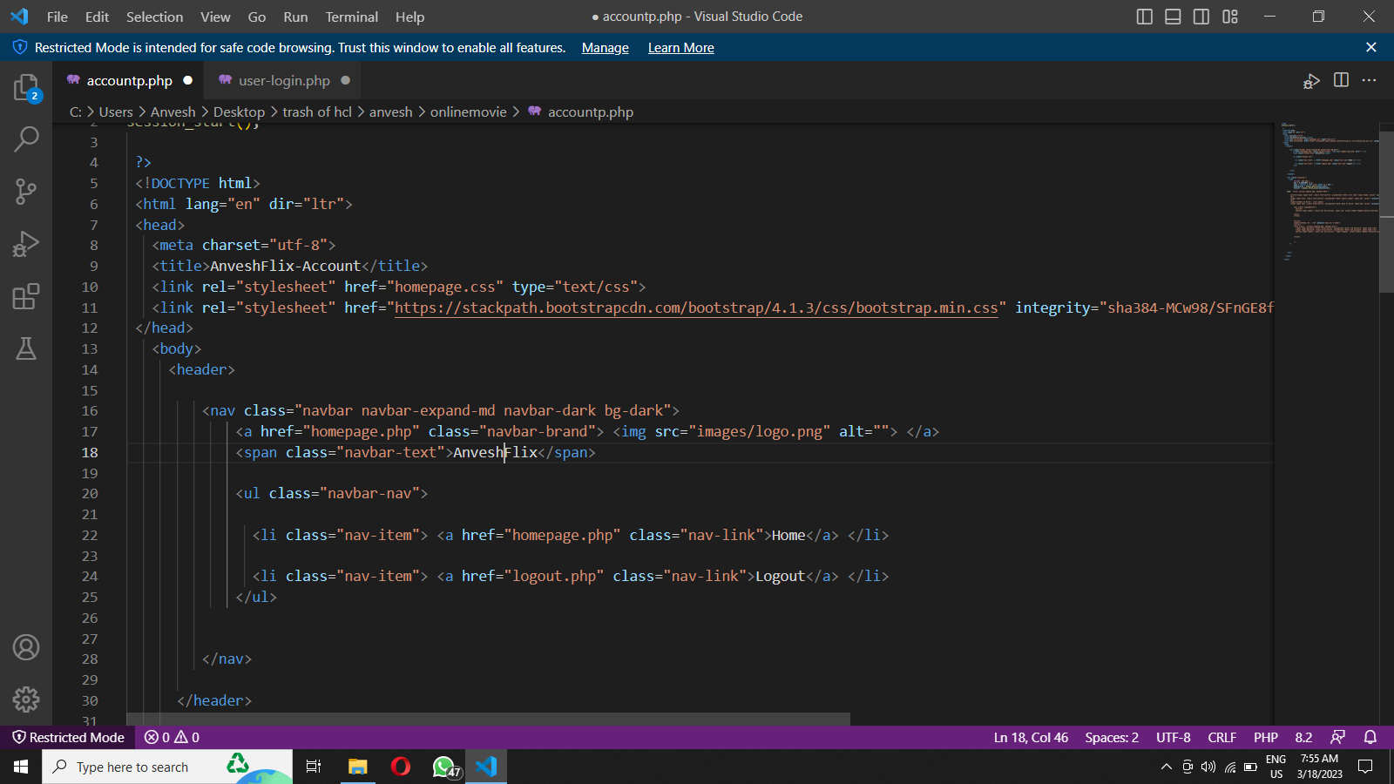

Fig 4.1: Account code

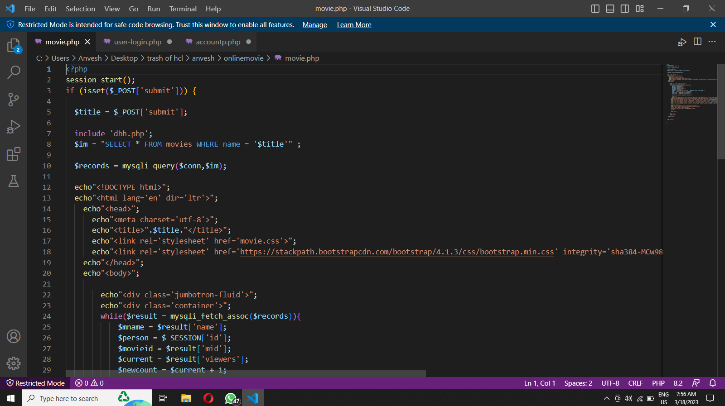

Fig 4.2: Designing movie code

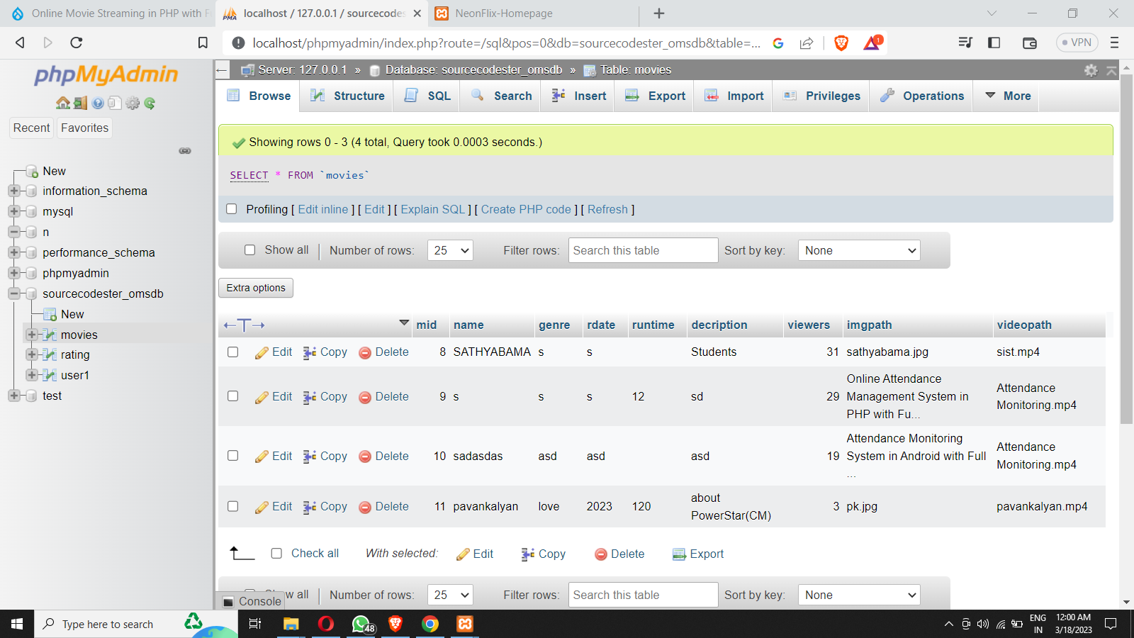

Fig 4.3 : Adding movies into the account

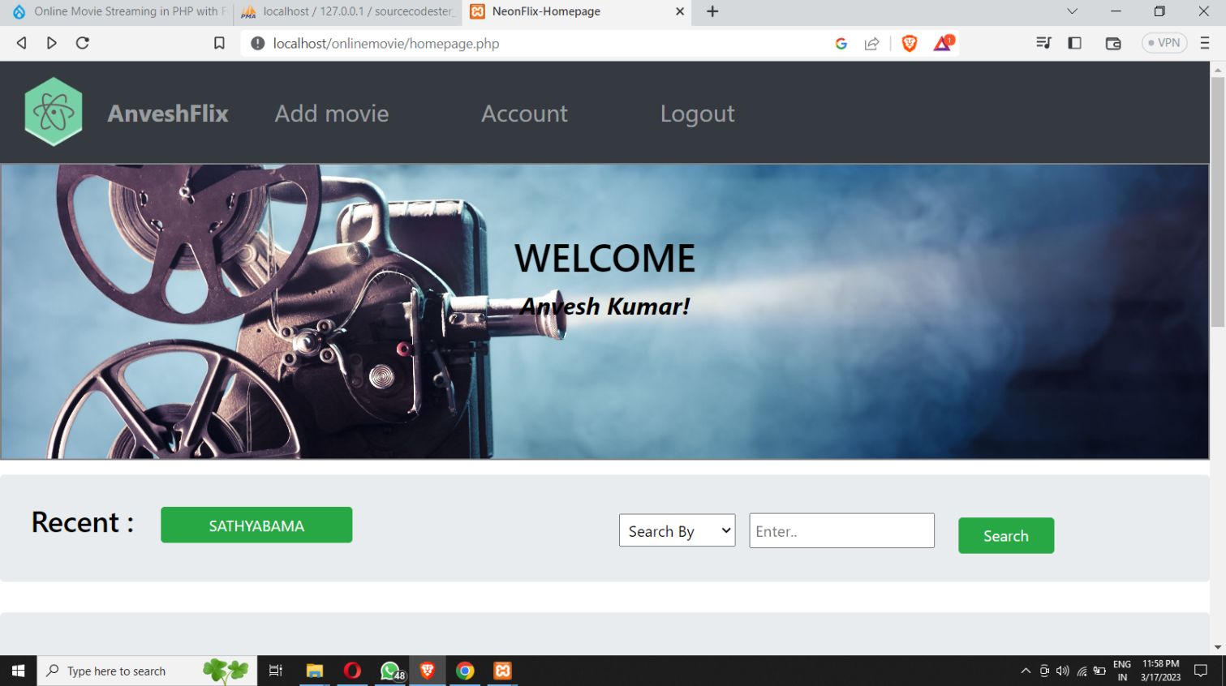

**Fig 4.4: Final Output**

**CHAPTER 5**

# CONCLUSION

Technology have been evolving day by day. Every day there is new products are launched. So, we have decided to change our previous traditional system with a fully functionality which include new features that are not available in existing system. We use different methods and software developing tools for developing our system. It will be useful for any college and university students who want to use and know new technology and it will be convenient for them. They will get rid from compulsory attending the classes because sometimes students may busy in urgent work and can’t reach in the class on time.

Video technology is always changing to keep up with consumer demand and individual and organizational inventiveness. Today, we're seeing the rise of new virtual (video-based) social interactions, quicker content delivery procedures, and services that provide the highest-quality content to any device with almost any bandwidth. This blog post served as an introduction to video streaming technologies

**REFERENCES**

* Anonymous. (2017, 7 4). Retrieved from Wikipedia: https://en.wikipedia.org/wiki/Online_lecture
* TechSmith. (2019, 8 5). Retrieved from Techsmith.com: https://www.techsmith.com/blog/lecture-capture/
* Software Engineering a Practitioner's Approach - Roger S Pressman – Fifth Edition.